Name: Pranali Sonawane
Subject: MCSA
Date: 5-1-2026
Lab 20: DFS

- Server 2 is remove Child Domain (Azure):
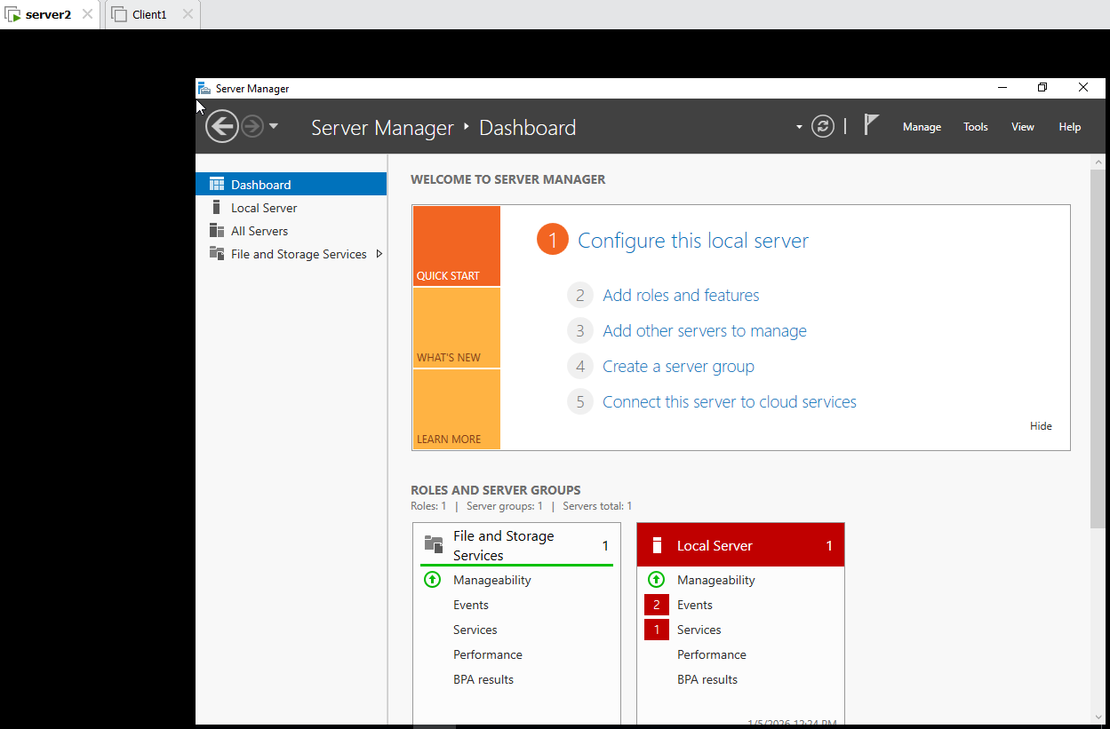
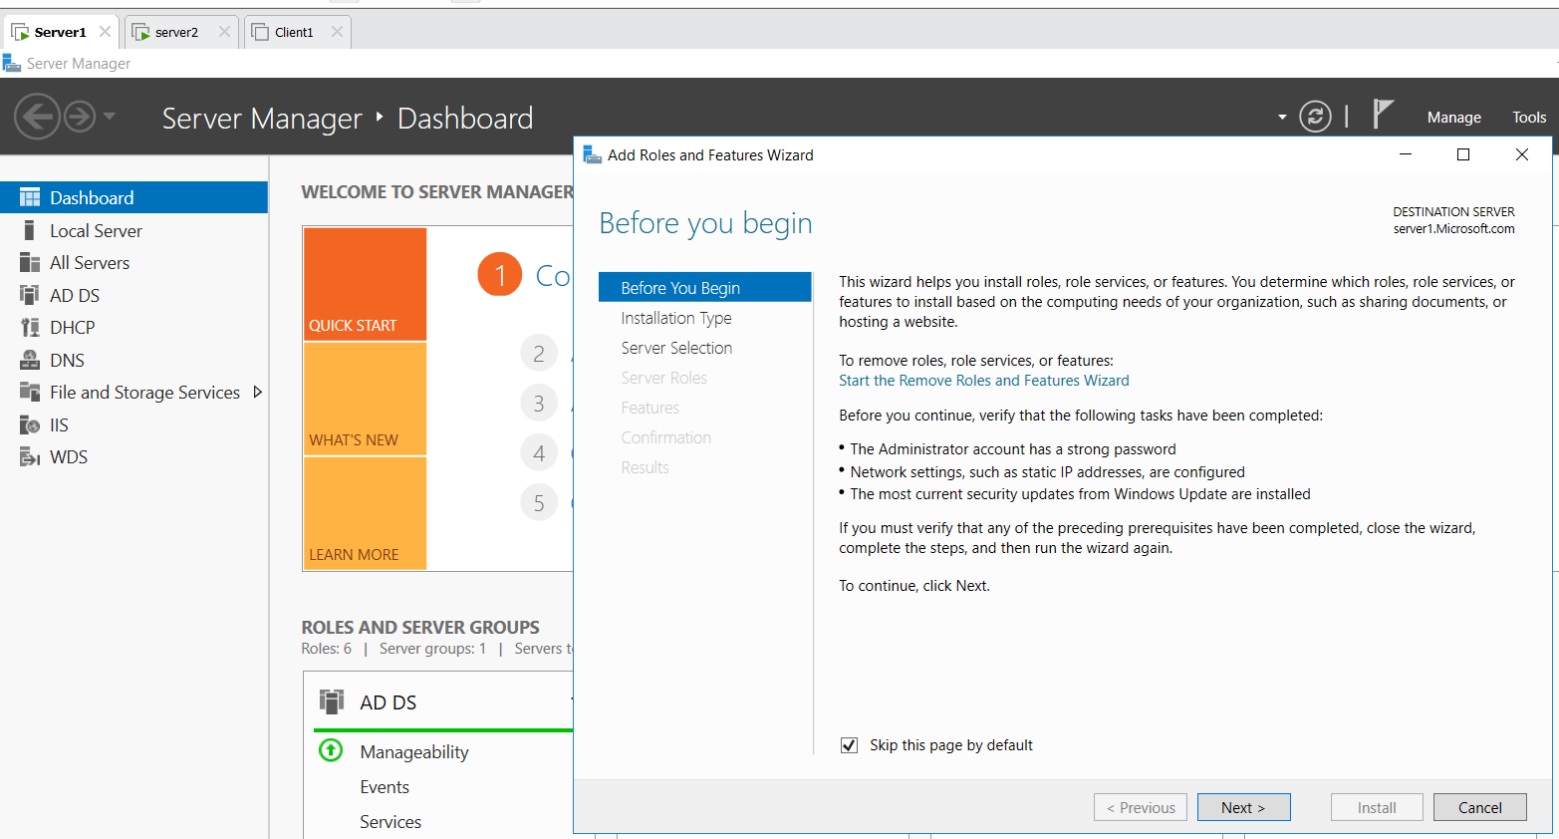
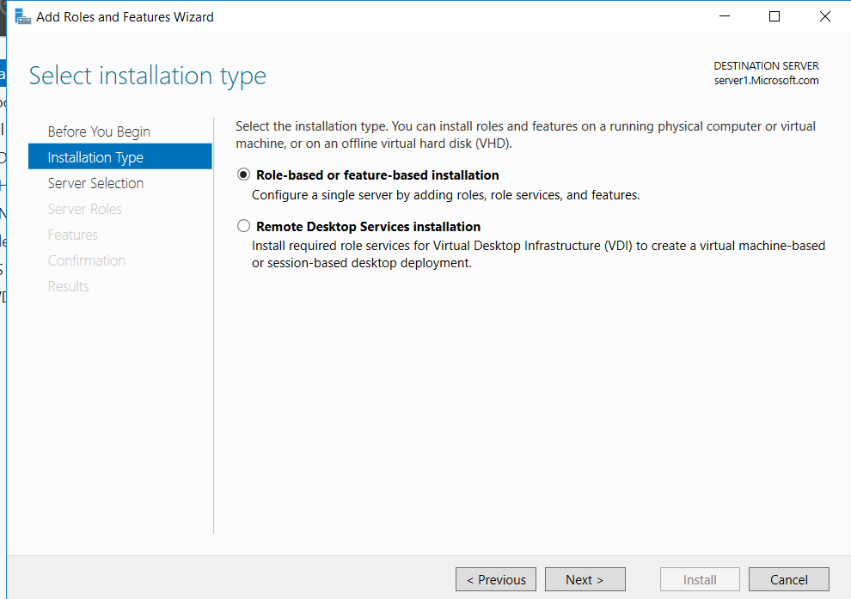
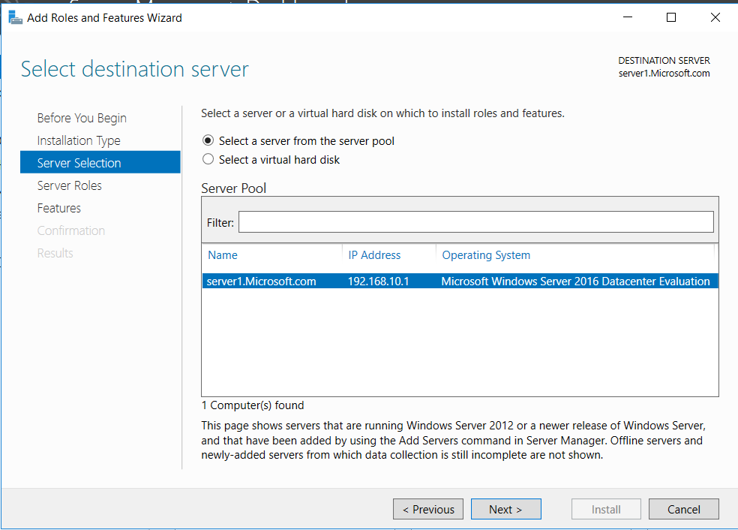
- Select Active directory Domain Service and DNS Remove Features Demote this Domain Controller Select Last Domain Controller in the domain Proceed with removal Click on Checkbox next give Password click on Demote .
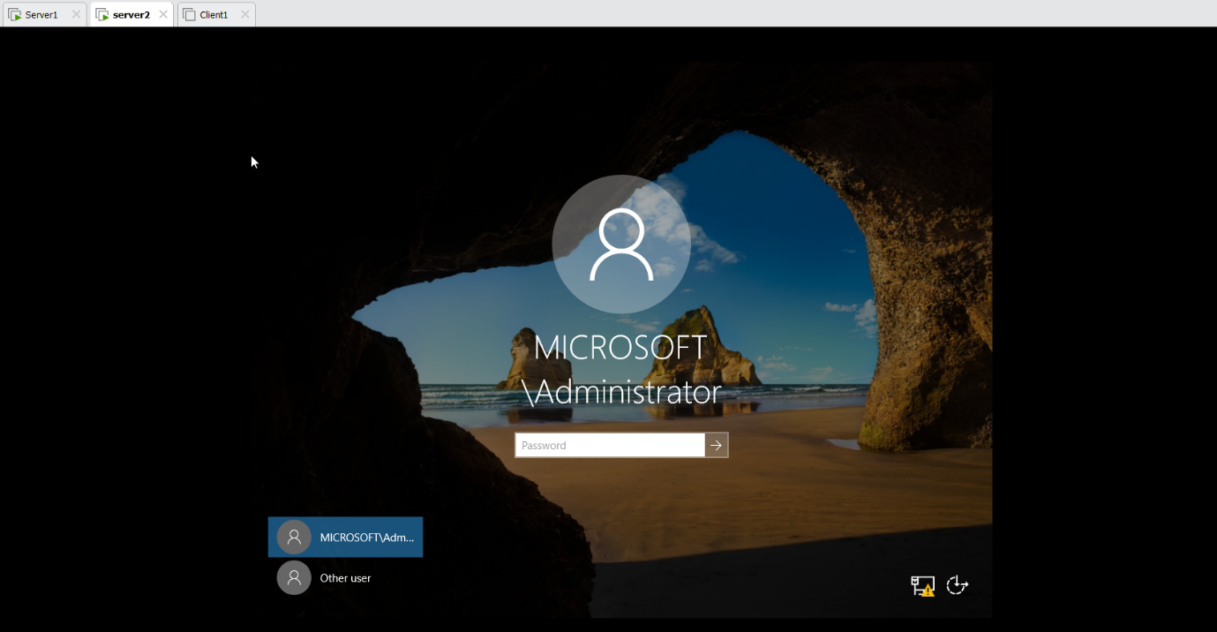
- Server 1: DFS Install
Add Roles and Features next next File and Storage Services Select DFS Namespace and DFS Replication next install
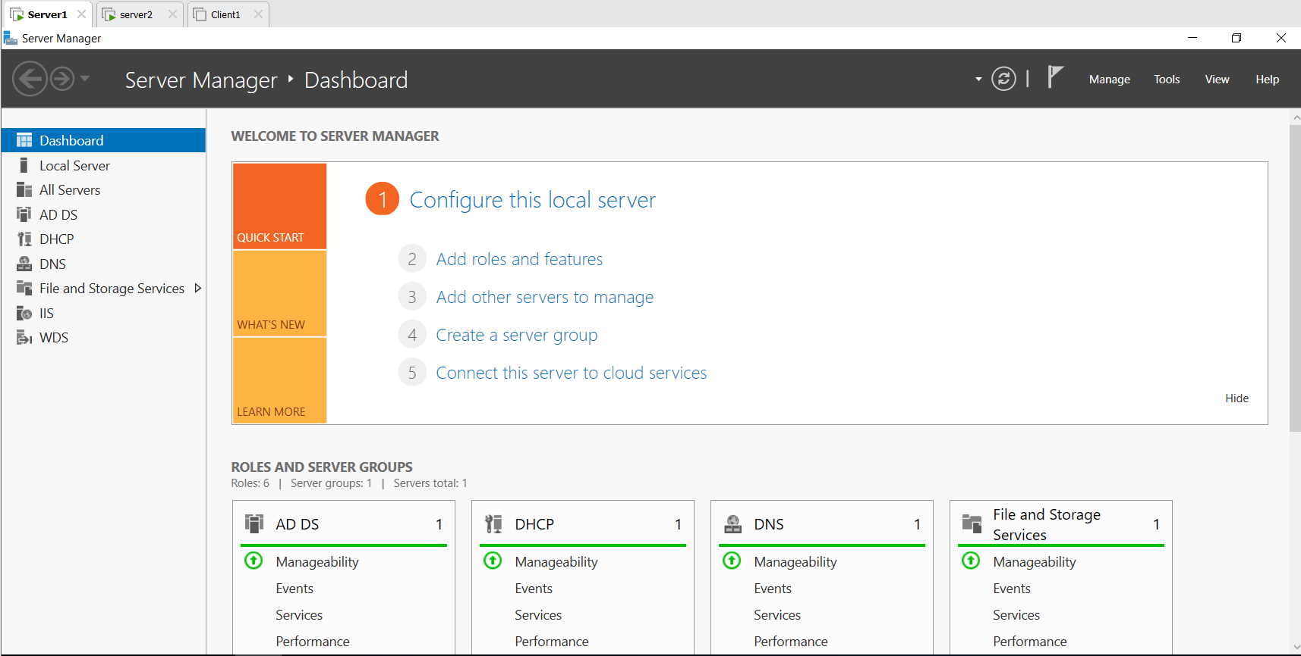


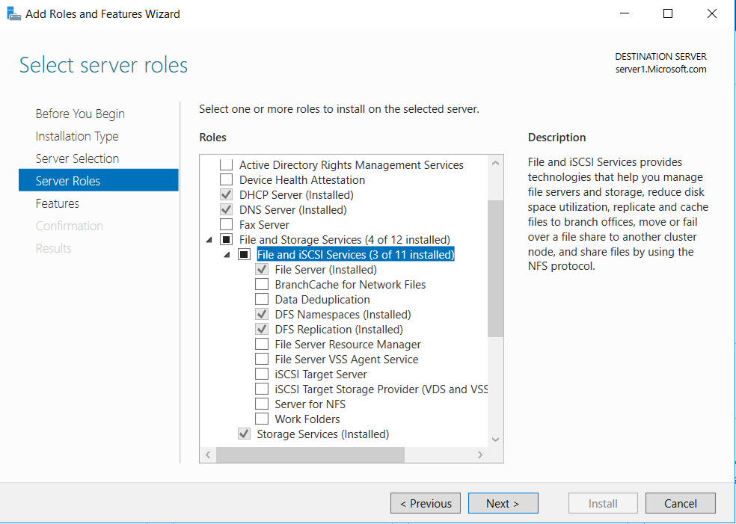
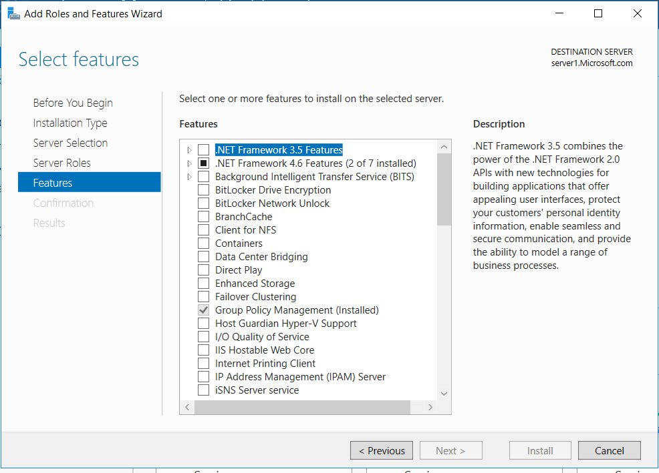

- Server 2: DFS Install
Add Roles and Features next next File and Storage Services Select DFS Namespace and DFS Replication next install

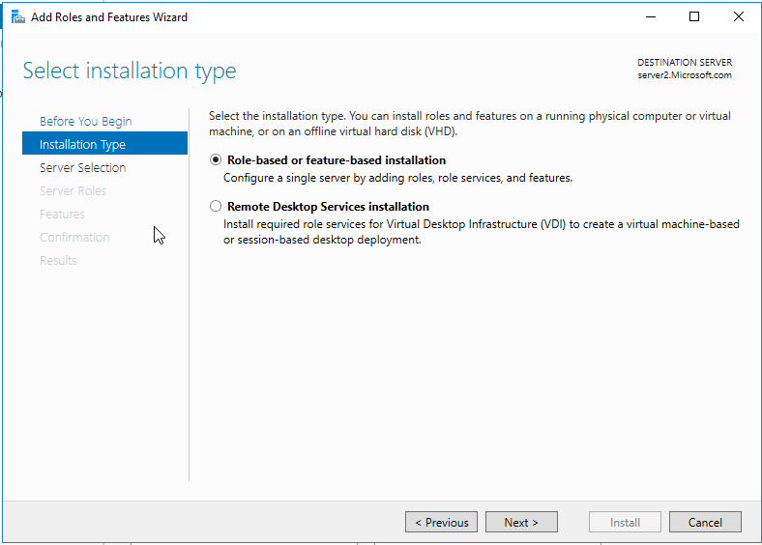
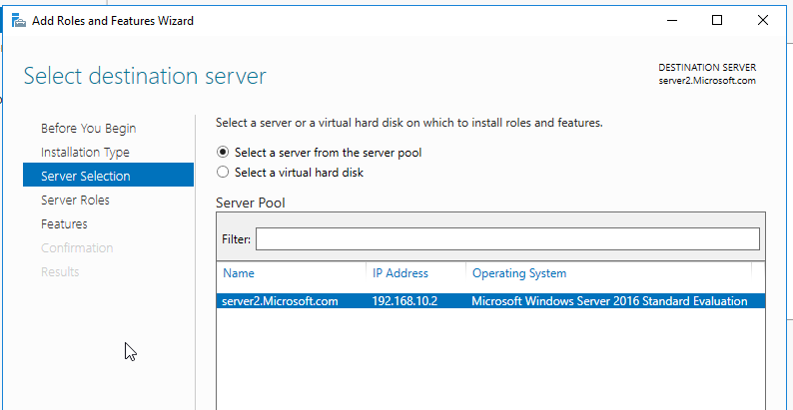
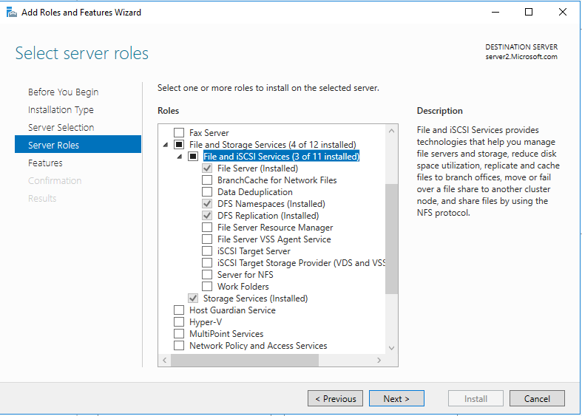
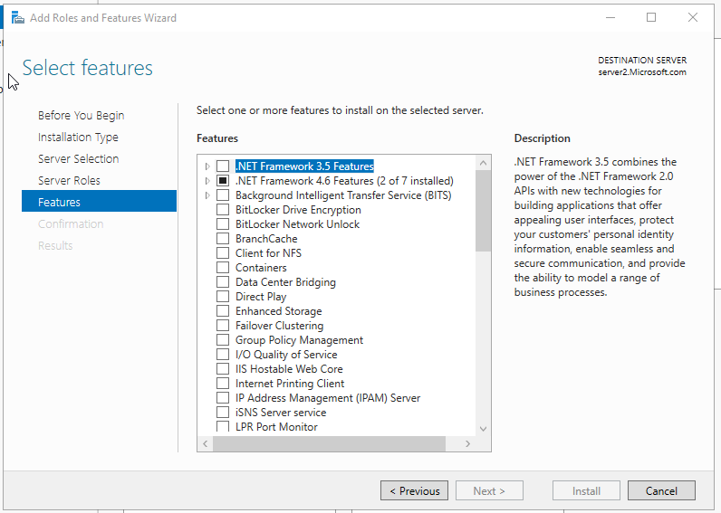
Check Server2 IP address and give Preferred DNS : 192.168.10.1
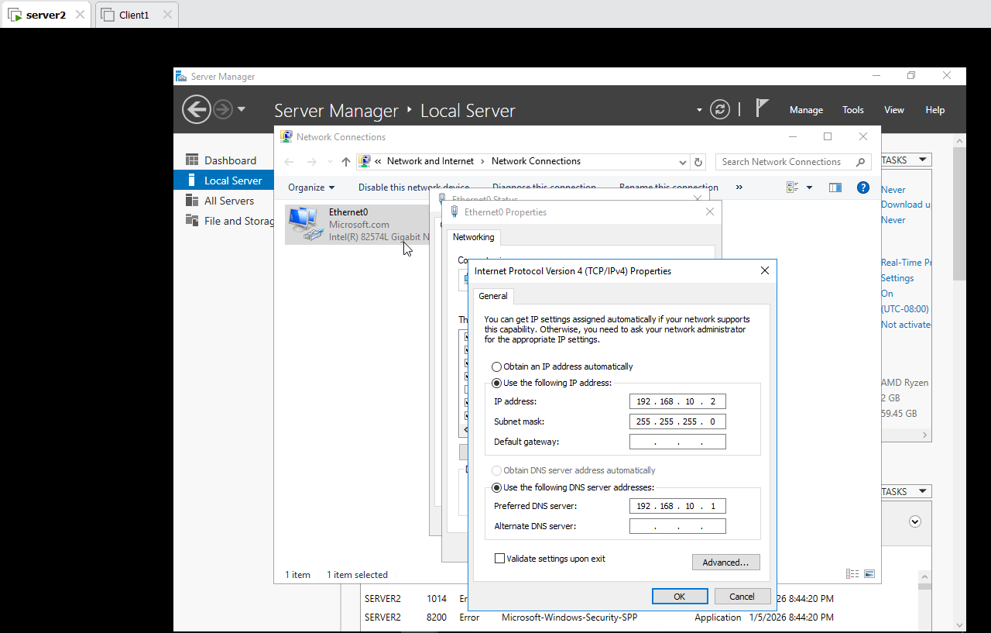
Server 2 add Domain of Microsoft.com give username and Password : Administrator and Password@123
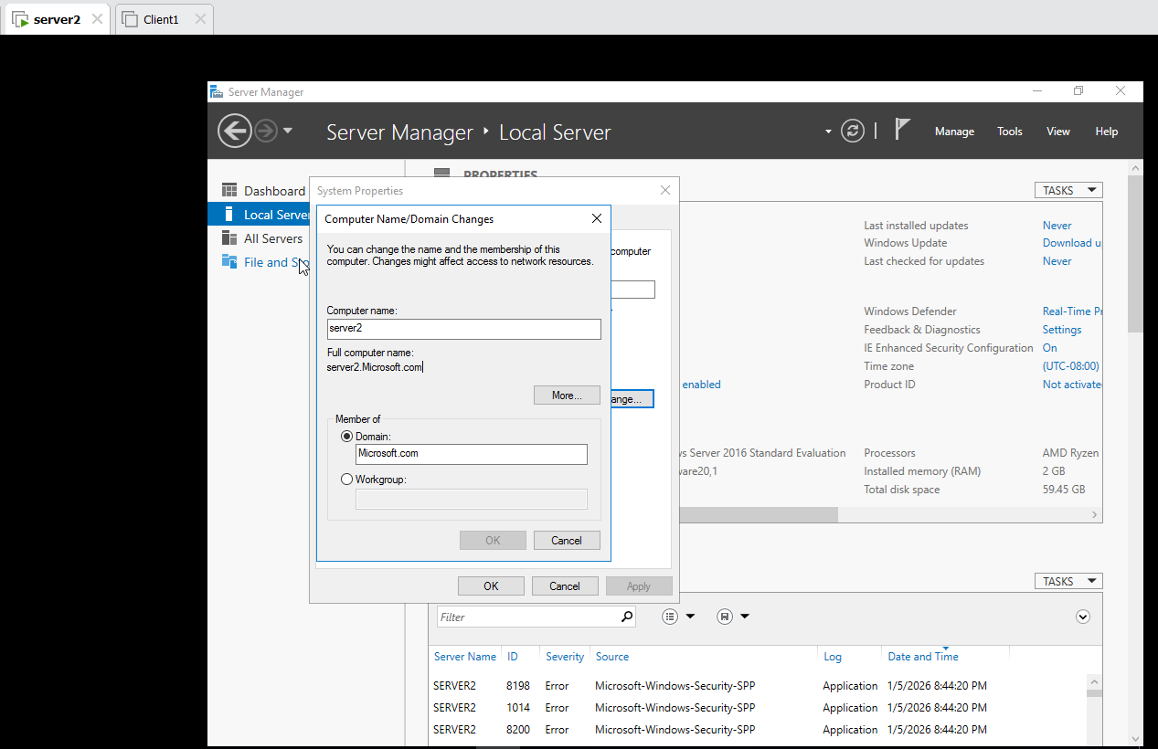
In Client 1 : It’s Member of Azure and Delete it.
How ?
Go to the Setting About Add Workgroup Restart.

Next
Go to the Setting About Add Microsoft.com give username and Password : Administrator and Password@123.
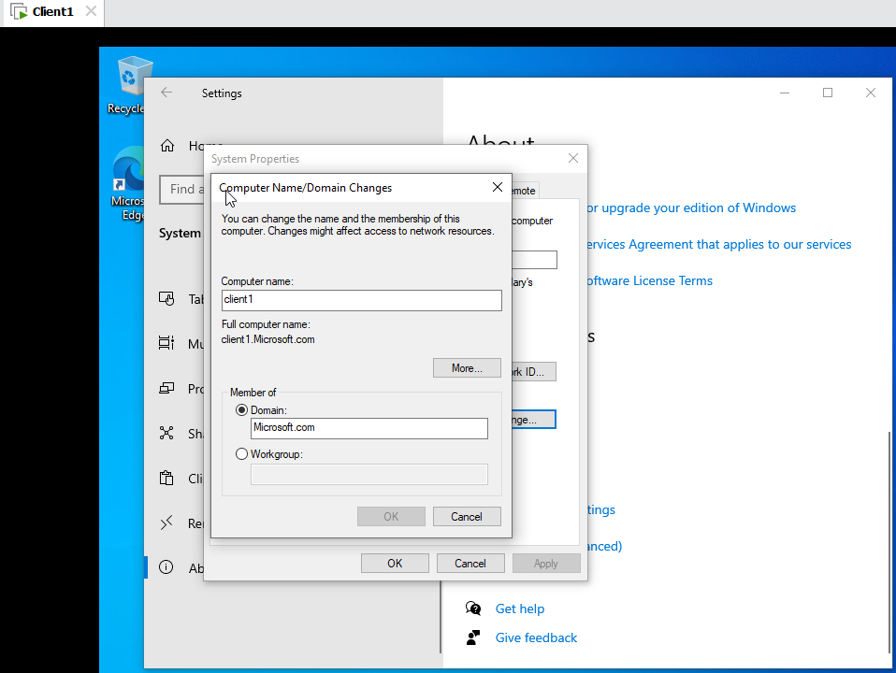
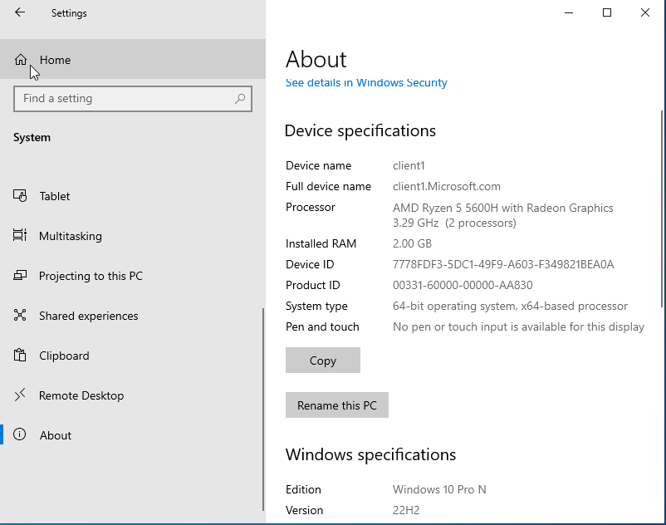

Server 1 :
In C drive Create Folder Hr1 in that Create File hr1 give any message .
In Hr1 give sharing Permission – Full Control and Security Permission – Full Control .
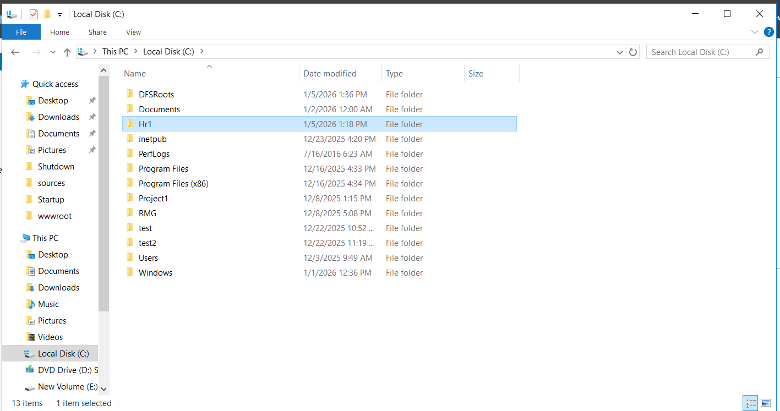
Server 2:
In C drive Create Folder Hr2 in that Create File hr2 give any message .
In Hr2 give sharing Permission – Full Control and Security Permission – Full Control .

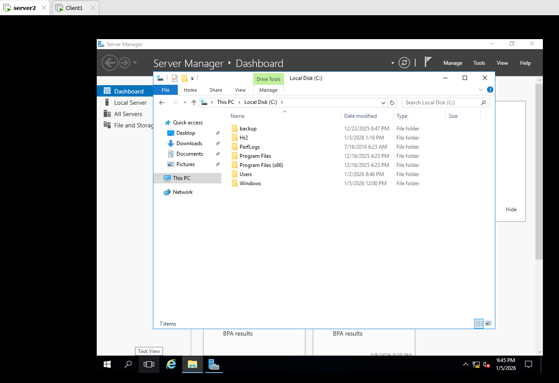
Client 1:
In C drive Create Folder Hr3 in that Create File hr3 give any message .
In Hr3 give sharing Permission – Full Control and Security Permission – Full Control .
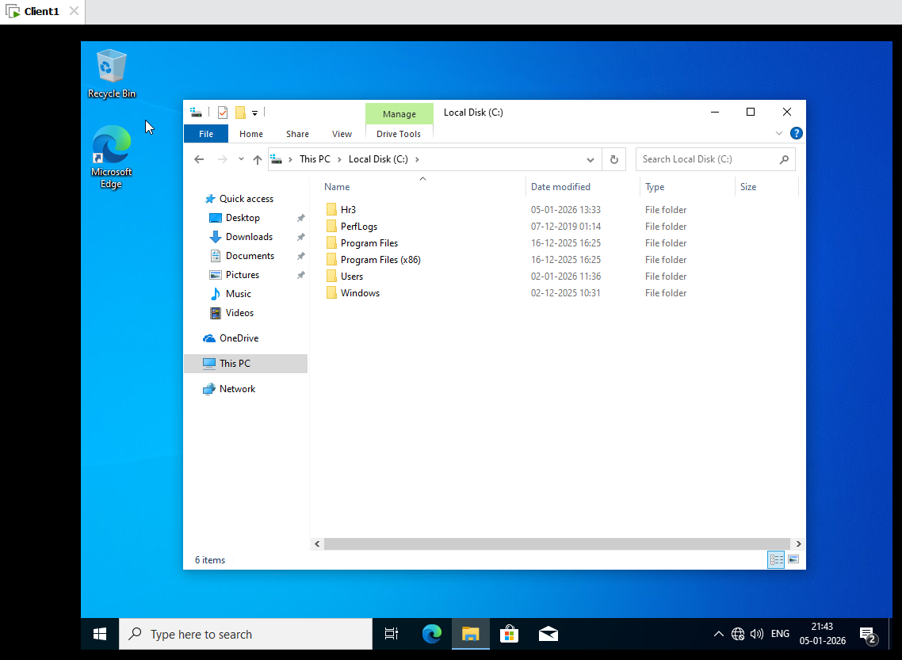
In Client1 :
Computer Management Local users and Computers Users Administrator Right Click Set Password Proceed ok.
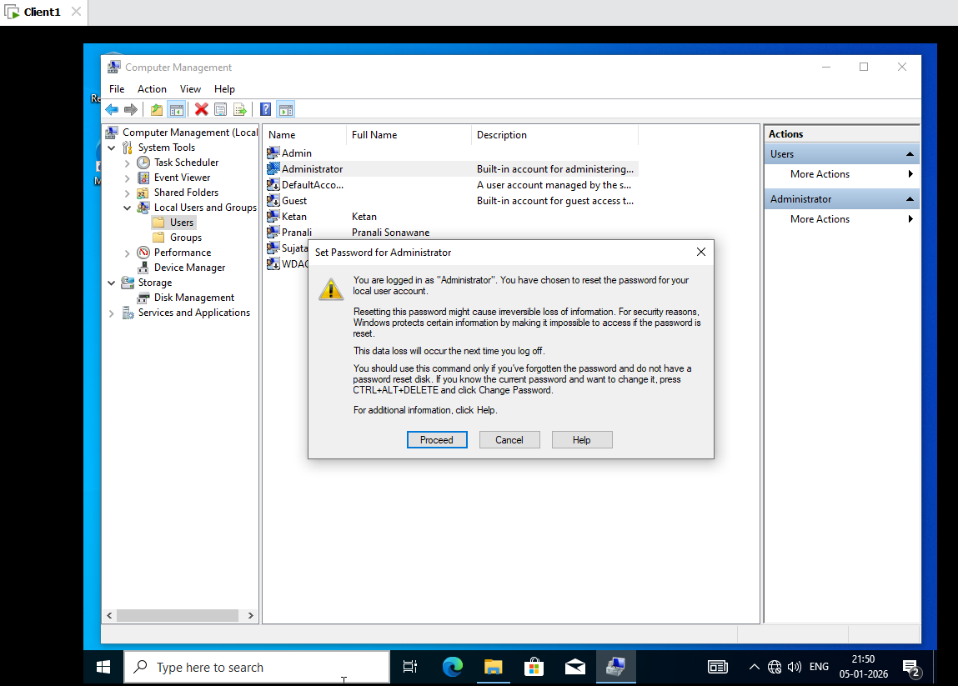

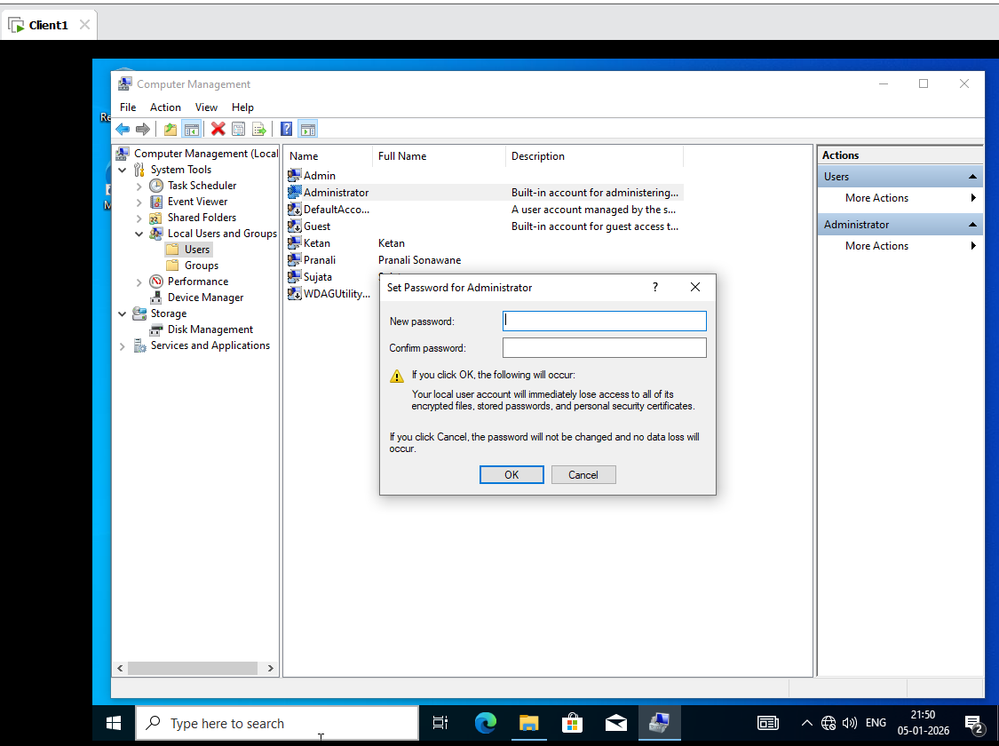
Server 1 :
Tools DFS Management Namespace Add Give name Server1 Give HR
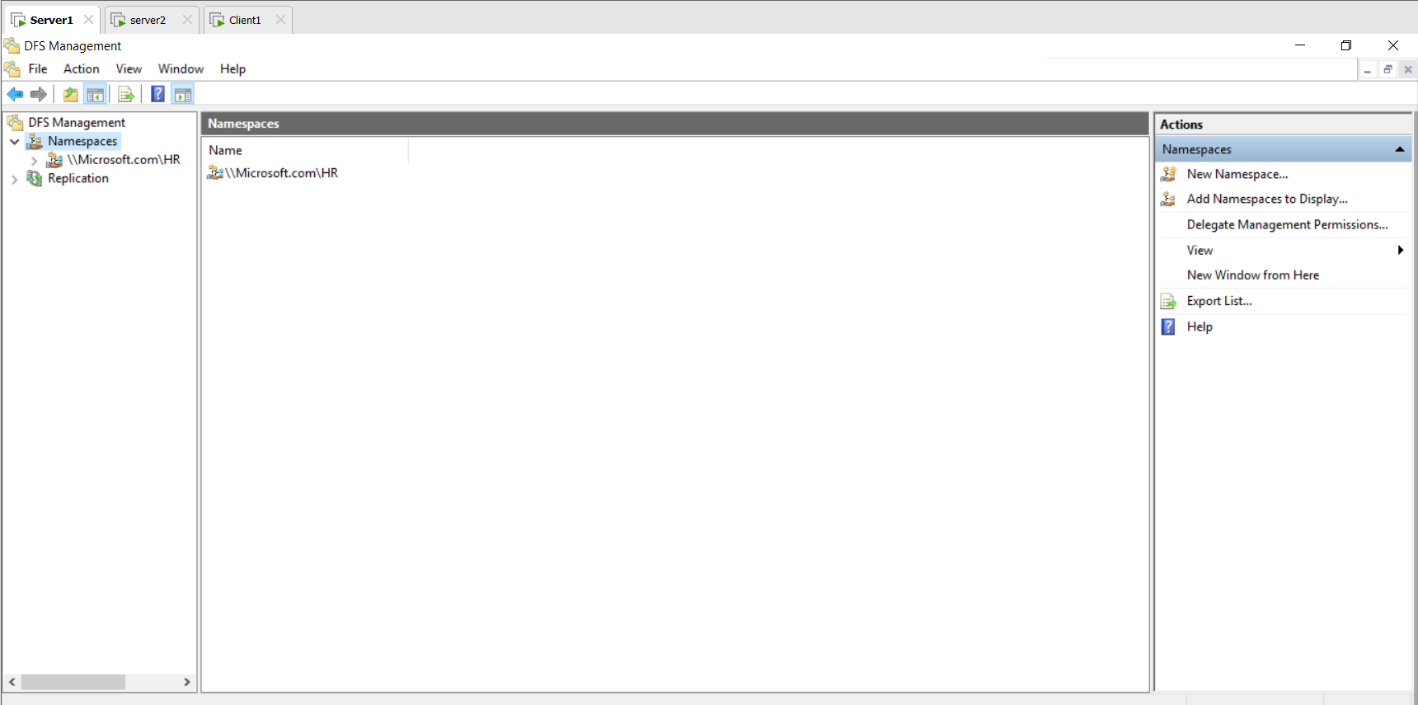
Click Microsoft.com\HR
New Folder name hr1 give path \\server1\hr1
New Folder name hr2 give path \\server2\hr2
New Folder name hr3 give path \\client1\hr3
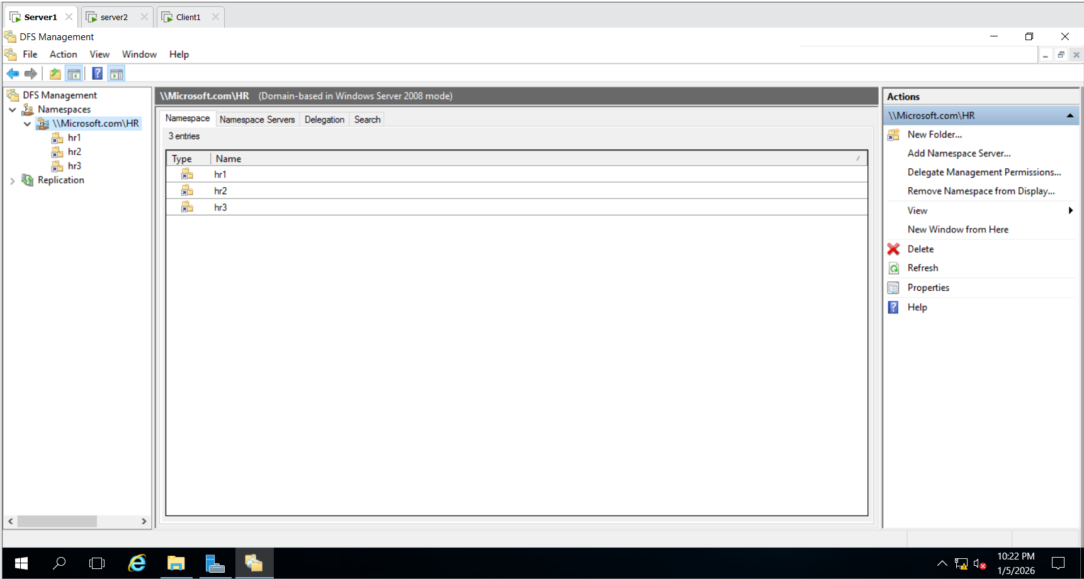
Check DFS on server 2:
Run \\server1 HR Folder Shown hr1,hr2,hr3 Folder Shown
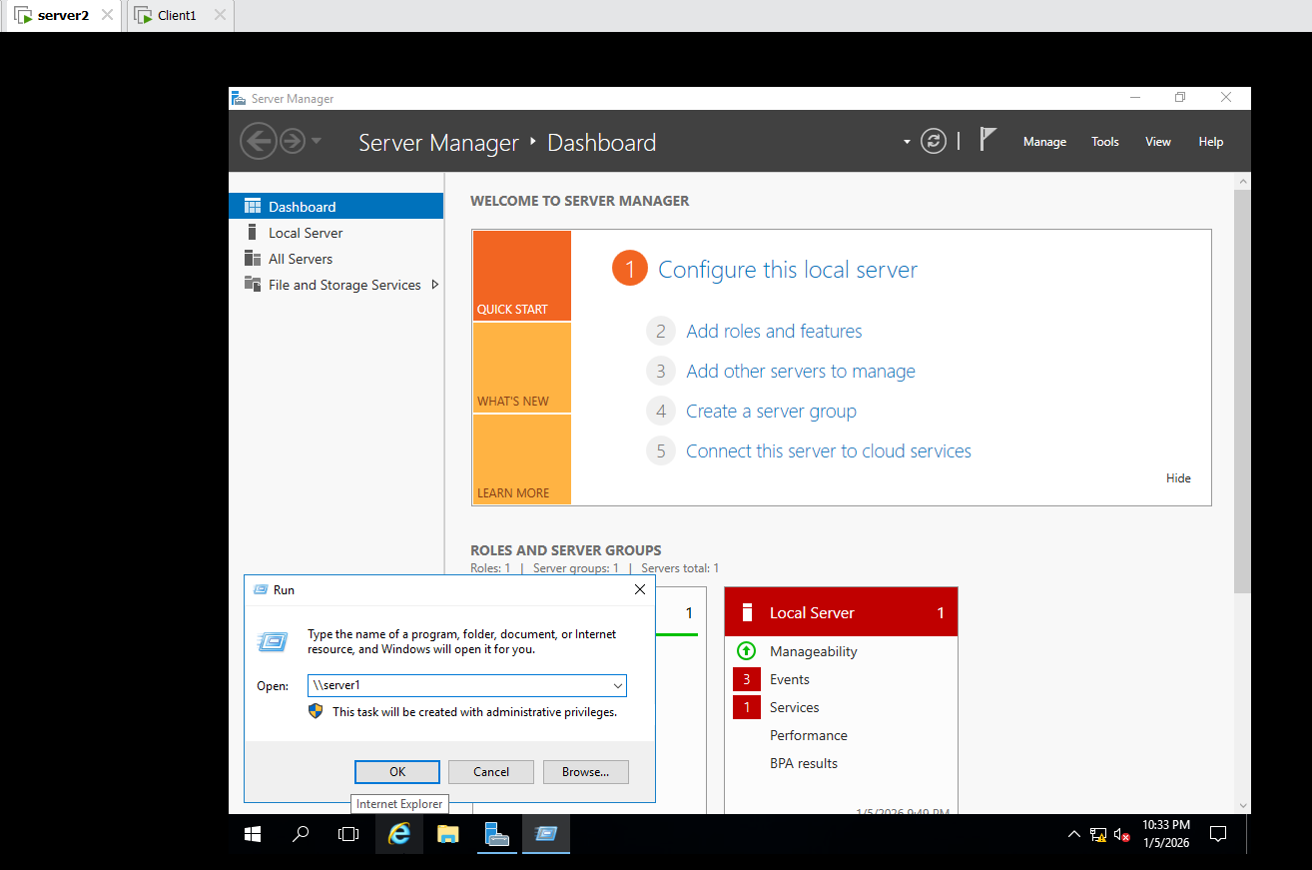
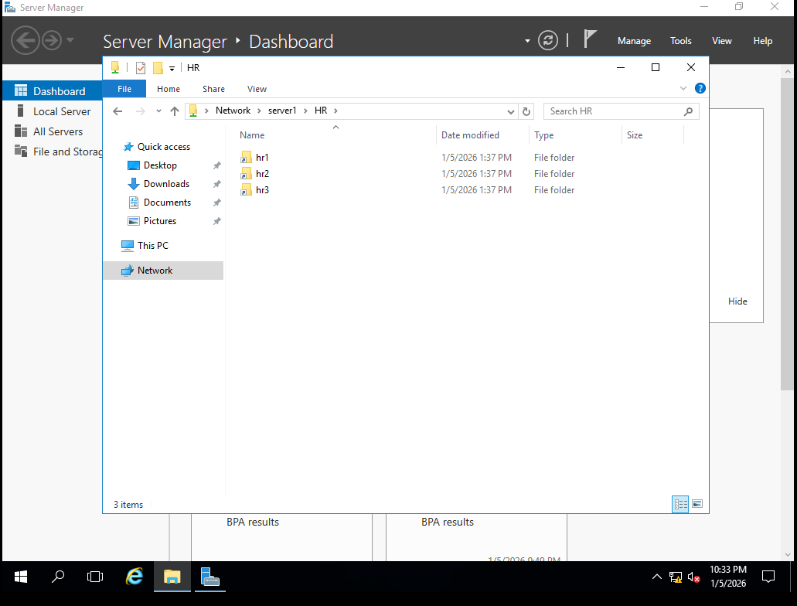
Check DFS on Client 1:
Run \\server1 HR Folder Shown hr1,hr2,hr3 Folder shown
